IRCC’s CORE Principles underpin all programming funded under the Settlement Program and the Resettlement Assistance Program. As funding applicants, you are expected to incorporate these principles in the design, implementation and evaluation of your proposed project(s), and articulate how you have done so in your application. IRCC’s assessment of your application will take these principles, along with obligations related to official languages, into consideration, as outlined below.

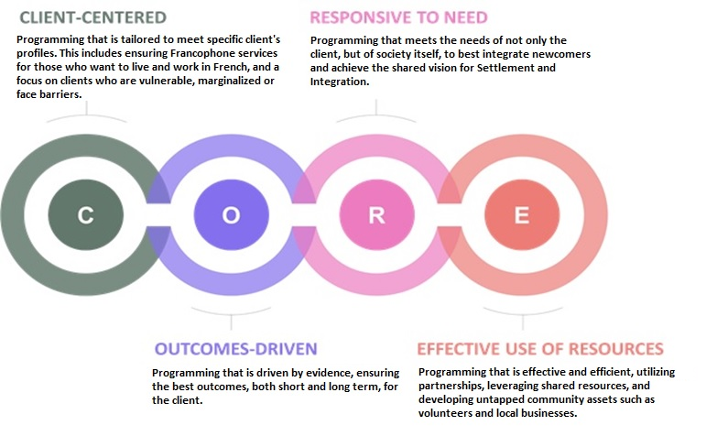

**Client-centered**

Programming that is tailored to meet specific client`s profiles. This includes ensuring Francophone services for those who want to live and work in French, and a focus on clients who are vulnerable, marginalized or face barriers.

**Outcomes-driven**

Programming that is driven by evidence, ensuring the best outcomes, both short and long term, for the client.

**Responsive to need**

Programming that meets the needs of not only the client, but of society itself, to best integrate newcomers and achieve the shared vision for Settlement and Integration.

**Effective use of resources**

Programming that is effective and efficient, utilizing partnerships, leveraging shared resources, and developing untapped community assets such as volunteers and local businesses.

**2.1 Client-centered**

Client-centered programming meets client needs by asking and listening to newcomers, to understand: their circumstances; their needs; their assets; what services are the most useful to them; and, how, when and in what language these services should be provided. Where feasible, services should be accessible at the time and location most effective for the client, including online or mobile ‘locations’. Programming should address barriers that might affect access to services, which can vary by client group. Service provision should also take into account the government-wide commitment to supporting the vitality of Francophone minority communities and official languages ([see section 3](https://www.canada.ca/en/immigration-refugees-citizenship/corporate/partners-service-providers/funding/call-for-proposals-2019-settlement-and-ressetlement-funding-guidelines.html#Official_languages)). This should include providing services in the official language of the clients’ choice wherever possible, ensuring full awareness of, and referrals to, Francophone organizations.

**2.2 Outcomes-driven**

Outcomes-driven programming is based on evidence and data. It is designed to provide the best outcomes for clients from the beginning to the end of their resettlement and/or settlement journey. It means being able to track both project **outputs** and measure client **outcomes** to recognize success in the immediate, intermediate and long term.

**Outputs vs. outcomes**

* **Outputs** are the result of activities you are proposing to undertake (for example, number of community connections services rendered, number of clients served).
* **Outcomes** are what changed as a result of the delivered outputs (for the client, the community, employers, etc.) (for example, percentage of community connections clients who indicate that they increased their social networks as a result of participation in IRCC-funded services).
  + Outcomes are defined as **immediate** (within 1 year from participating in the service) focused on changes in knowledge, skills, and networks; **intermediate** (1 to 5 years since participating in services) focused on the use of acquired skills and knowledge to support independent decision making, participation in labour market or in society, and **ultimate** (beyond 5 years since participating in services) focused on integration within society.

**2.3 Responsive to need**

Resettlement and settlement programming seeks to meet the needs of as many eligible clients in a community as possible. It also helps host communities strengthen their capacity to welcome and retain newcomers. This includes addressing systemic barriers that hinder the integration of newcomers (including their opportunity to become Canadian citizens), and increasing involvement of specific sectors of the community to support multi-sector involvement in newcomer integration strategies for your geographic area.

It also encourages programming that creates meaningful dialogues and connections between newcomers and Canadian citizens, including Indigenous peoples, recognizing that cross-community interactions are an important part of the settlement and integration process for newcomers and their receiving communities. This includes addressing common barriers to citizenship or experiences of exclusion affecting different minority groups, and to identify what members of each community might do to support each other’s inclusion.

There should be a clear need for the project, supported by evidence and data. Project goals should be feasible, with clear links to one or more base and/or customized services. Programming should be adaptable to changing needs and circumstances of newcomers and their host community. Finally, applications will be looked upon favourably by IRCC if they articulate connections to strategic plans produced by Local Immigration Partnerships and/or Réseaux en immigration Francophone where possible.

Applicants should be maximizing current and emerging technological solutions so that programming is more effective, flexible, and accessible. IRCC is interested in programming that reduces barriers that may impact a client’s ability to use online or digital services (for example, lack of digital literacy and/or insufficient Internet, computer or mobile access, etc.).

For example:

* Expansion of online and blended[Footnote 5](https://www.canada.ca/en/immigration-refugees-citizenship/corporate/partners-service-providers/funding/call-for-proposals-2019-settlement-and-ressetlement-funding-guidelines.html#fn5) options for services to increase the ease of access; improving access to and the use of technology and mobile platforms to make settlement services more readily accessible regardless of the client’s location
* Coordinated, collaborative promotional activities that leverage the use of social media to improve outreach to newcomers to increase awareness of services offered
* Promotion of blended and online settlement services

Applicants should have the necessary capacity to deliver effective programming to newcomers. Staff must have sufficient knowledge and training to deliver effective services. IRCC encourages training to support projects submitted through this Call for Proposals. This includes tools and skills development that are tied directly to ensuring that direct settlement services within a proposed project can be delivered competently by frontline staff.

Applicants are encouraged to indicate any cost associated with staff training directly linked to the delivery of the specific project in their budget.

**2.4 Effective use of resources**

There are finite resources, and an ever-growing need for Settlement and Resettlement Assistance Program services. This means that programming must be as effective and efficient as possible.

Partnerships (both new partnerships and deepening of existing partnerships), the nature of the partnerships (for example financial or service delivery agreements between organizations), leveraging of shared community assets and resources, and other innovative approaches can help us achieve the same or greater outcomes together, within resource constraints. Programming can also harness untapped resources, such as relevant technologies, new volunteers and businesses.

IRCC encourages programming approaches that engage partners in service delivery, and discourages unhealthy competition between proponents. IRCC is keen on harnessing the collective skills and knowledge within the settlement, resettlement, and other sectors by working together to achieve better outcomes for newcomers. Partners and approaches could include:

* community-wide division of labour with multiple service providers working on one project
* partners outside the settlement sector
* private sector and employers
* faith communities
* Indigenous peoples
* ethnic communities

Applications will be looked upon favourably by IRCC:

* If services are concentrated and consolidated in one agency on behalf of several where appropriate (for example one agency assessing clients and referring clients to the agencies who are best equipped) to provide services in a timely and effective manner
* Where a coherent division of labour is presented by multiple agencies to ensure comprehensive coverage of services across a geographic community (for example where multiple agencies partner to ensure youth programming is available in schools across the community without duplication of effort)

Similarly, applications will be looked upon favourably where flexibility is demonstrated to serve more or fewer clients depending on fluctuating landings, client numbers by country of origin, etc.